**POST (due WED 11:59 pm CST):**  Download and install [Lansweeper](http://www.lansweeper.com/) or [Spiceworks](https://www.spiceworks.com/" \t "_blank).   Use the application you have installed to discover assets on your home network or our campus.  Given the assets classification scheme we have learned this week, classify the assets you have discovered and describe what information about each asset class the application gives you.

**RESPONSES (due FRI 11:59 pm CST):**  Respond to two of your peers' posts.   Does the application, as your peer has used it, allow him or her to complete a full and comprehensive profile of the assets on his or her network?  Why or why not?

dy>

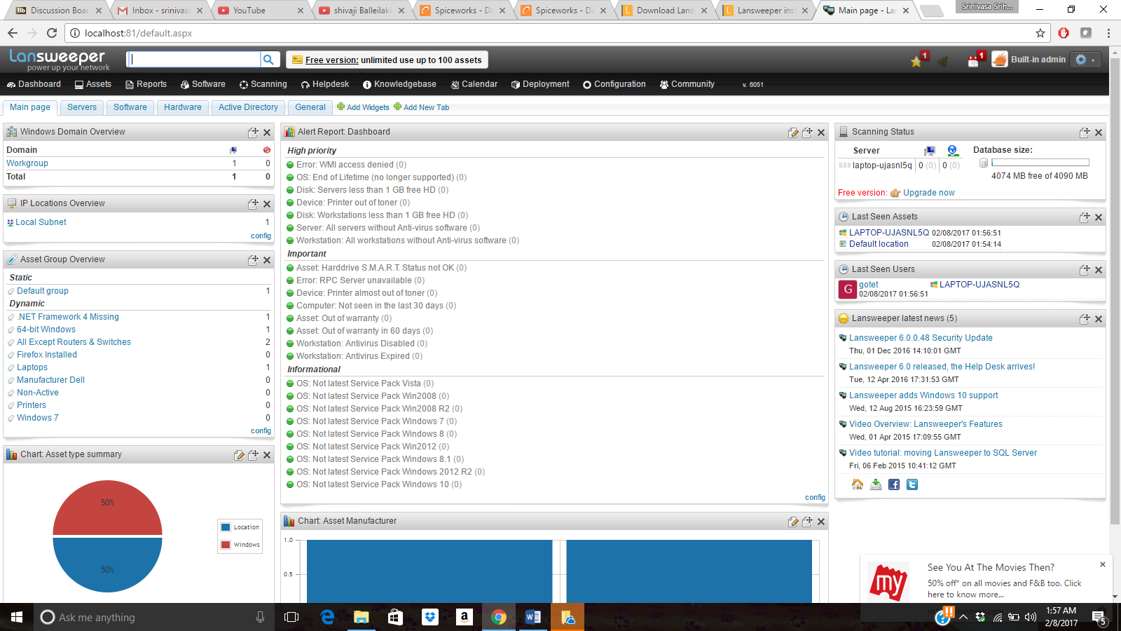  
  
  
  
  
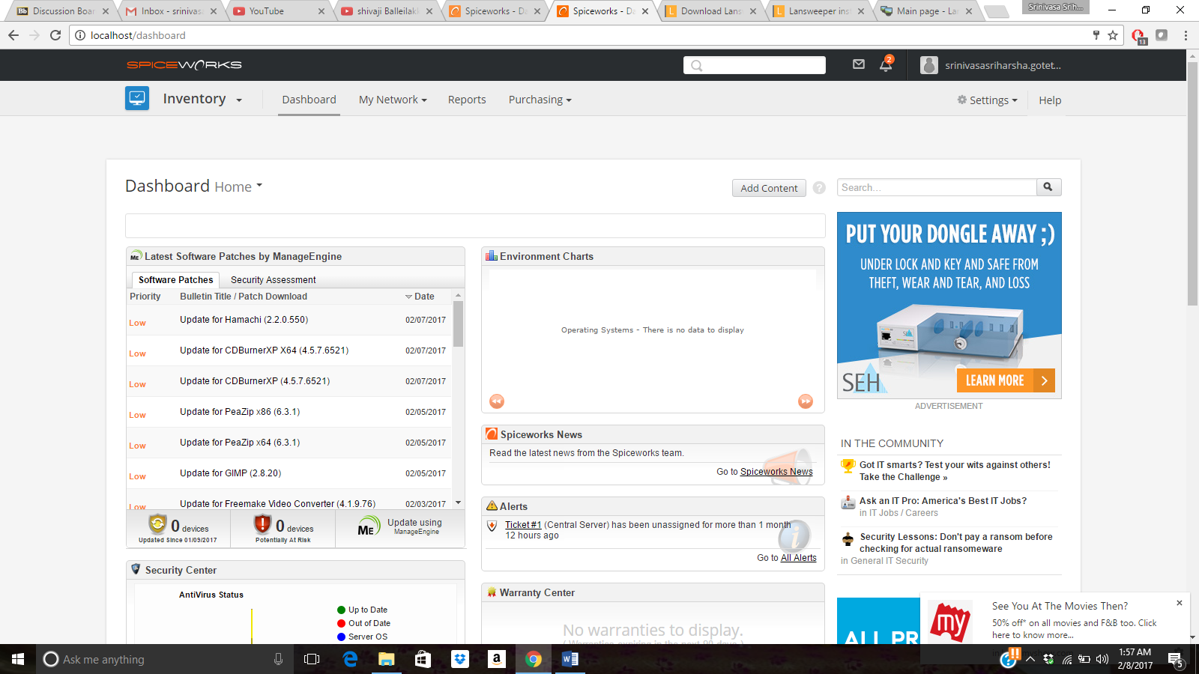  
  
  
  
  
  
Hello All,  
  
  
Thank you for taking your time for reading my research on assets management software named as Lansweeper and spice works. I had installed both on my system, where it would become a good platform for me to investigate for me regarding both the software application regarding my assets and being a system administrator, which would help for my experience, and make myself expertise in this field. Knowing about assets is something very important thing, which make your process and system more updated and effective, where I had investigated this software working functionality in my home environment. Creating ownership is something very important regarding making it with high level security and ensure that we have a bright level of security established for the organization where in organization we considered to have Information, personnel, hardware, software, legal assets. These software are something more important in terms of risk management to maintain all servers and system up to date and maintain proper track regarding it working in an organization. Identifying which system is having high priority and assessment regarding system related to the group, and regarding which pack is need to be updated and maintaining with updated configuration. Assest Management is something very important in terms of maintaining security feature , and also making the team updating with best working functionality and making them export using excel,csv and xml format, so that it can shared to people, and make them identified with updated work group. Knowing about config, and adding a new assest to the group if it not added is something very important feature for the organization benefits, and make them acknowledge that organization hardware, software and data and make them patent with the organization based emblem on the product and confirm that product belong to the organization and avoid any kind of forgery. Software update make them navigate with latest software region regarding the product on what software installed on the system. Product creation, and product expiration, is something is like a deadline regarding the product makes the product roll continuity. Products in the network need to be maintained with updated and security and generate reports with the latest updates and providing with Ip address and product developed by and the operating system on the server with a time stamp.  
  
  
Regards,  
Sriharsha Goteti